**Revision History**

|  |  |  |  |  |
| --- | --- | --- | --- | --- |
| **Section** | **Edition** | **Revised by** | **Date** | **Description** |
| All | 1.0 | Jans Lien. | 07/25/2024 | New |

Index

**1****Purpose :** 3

**2** **Scope：** 3

**3** **Definition：** 3

**4** **Reference：** 3

**5** **Contents：** 4

5.1 rsh setup: 4

5.2 Shell script programming(172.17.32.18): Script path: /usr/bin 4

5.3 Cacti Server, 172.17.32.16, setup for CPU, Memory usage display on Cacti server: 5

5.3.1 Input Method 5

5.3.2 CPU Memory Data Template Creation 8

5.3.3 CPU Memory Graph Template Creation 11

5.3.4 Host Graph Creation: 16

**6** **Attachment：** 17

1. **Purpose :**

This SOP provides the steps for retrieved the CPU and Memory usage information from the specific process on remote Linux server and monitor them for daily or any incident reference.

1. **Scope：**

TPV.

1. **Definition：**

Cacti Server: 172.17.32.16.

Remote Linux: 172.17.32.18. (Be monitored Server)

Cacti server will get the CPU and Memory usage of specific process on 172.17.32.18 and show graph on Cacti server.

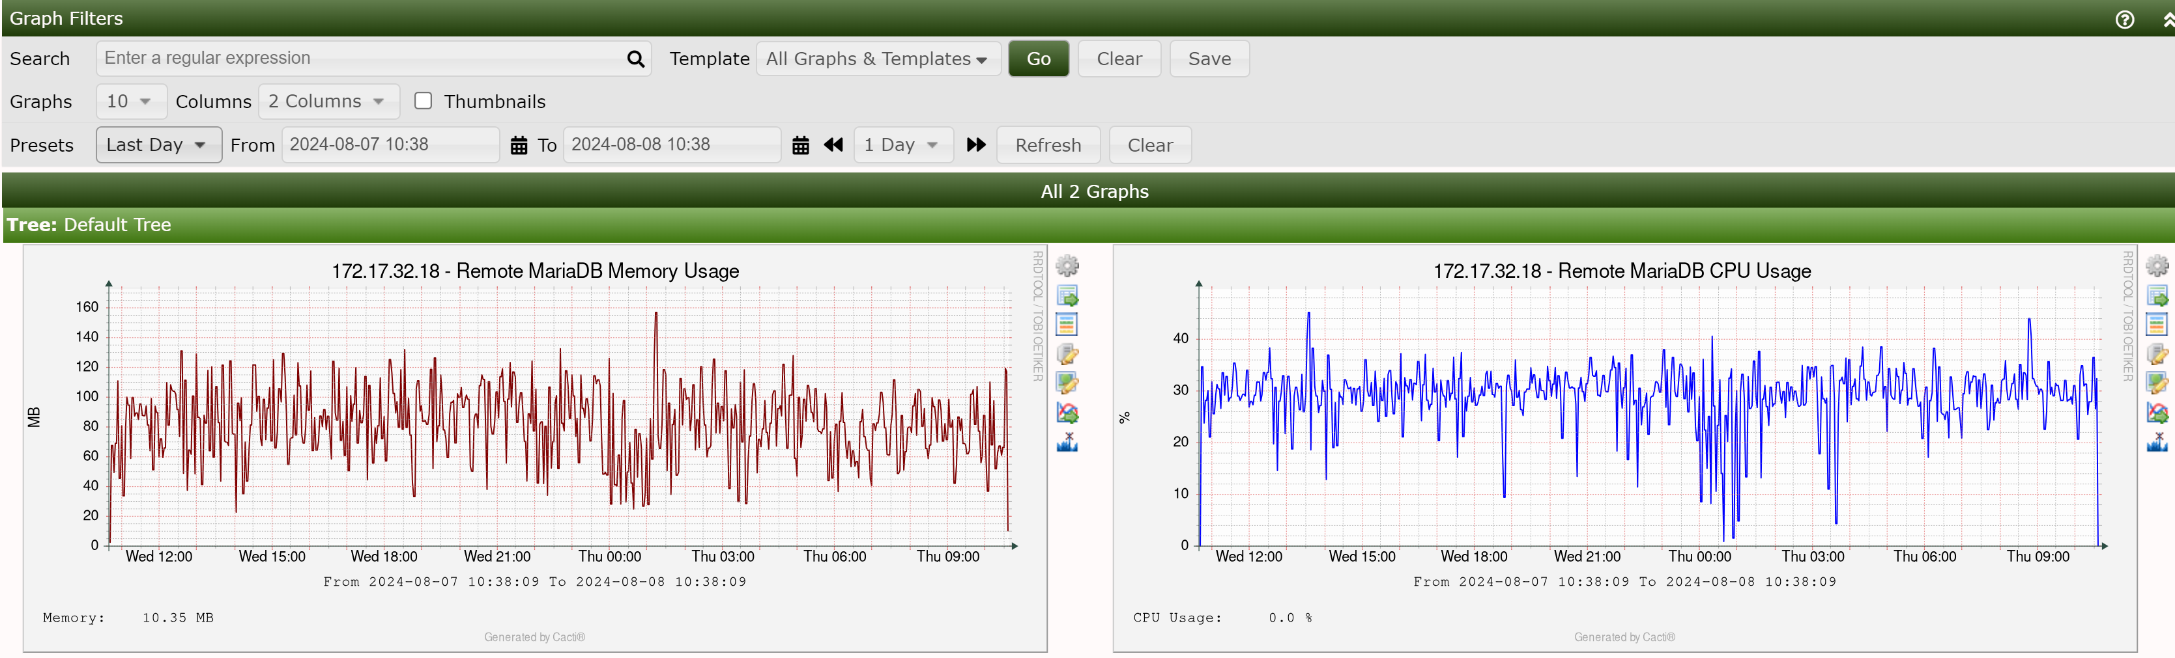

1. **Reference：**

None.

1. **Contents：**
   1. rsh setup:

add 172.17.32.16 + into /etc/hosts.equiv file.

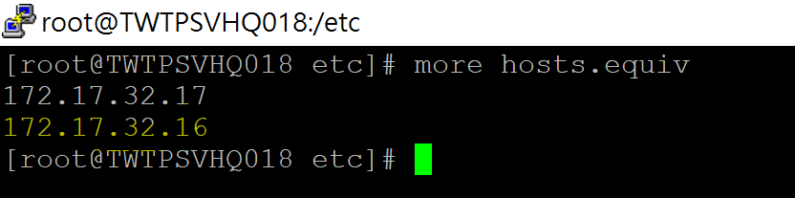

Create /home/apache directory and change it owner and group to apache on 172.17.32.18 linux server.

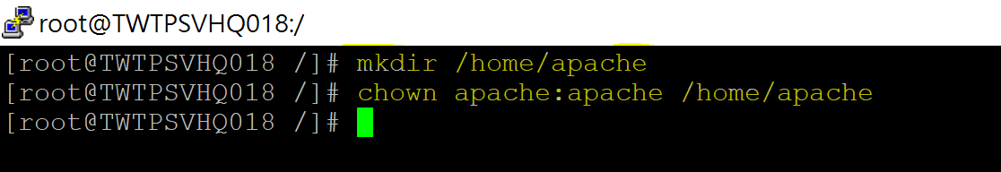

Add “172.17.32.16 apache” into /home/apache/.rhosts

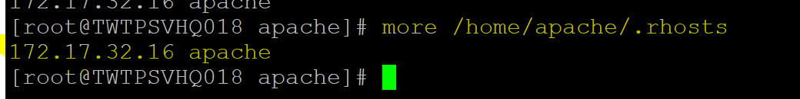

* 1. Shell script programming(172.17.32.18): Script path: /usr/bin
     1. Get CPU usage Script: Get the CPU usage data of ‘php’ process.

Show the full script below:

 is cpu_usage script.

The content of the script shows below:

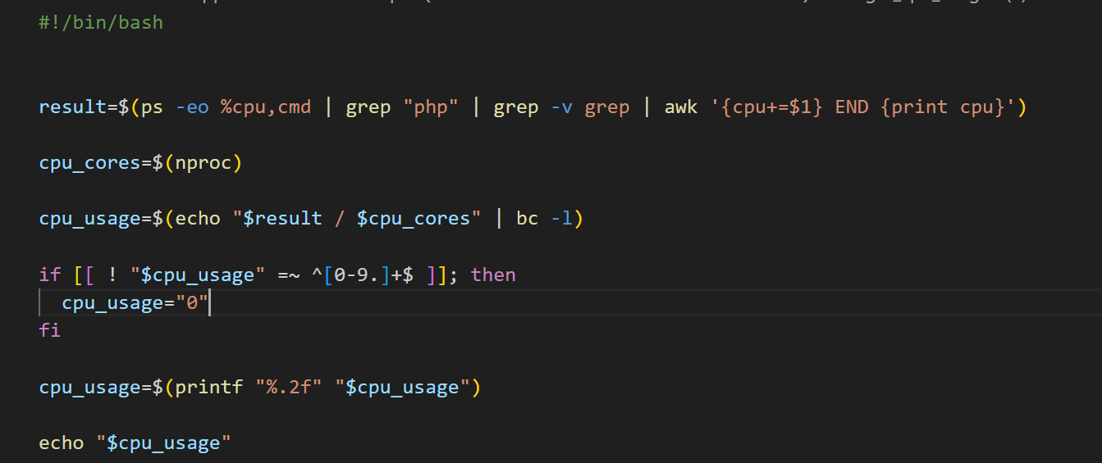

cpu_cores=$(nproc): number or CPU cores on Linux server.

cpu_usage = average CPU utilization. (Total CPU usage divided by cpu_cores).

* + 1. Get Memory usage script: Get the Memory usage data of ‘php’

process.

The content of the script shows below:

 is mem_usage script.

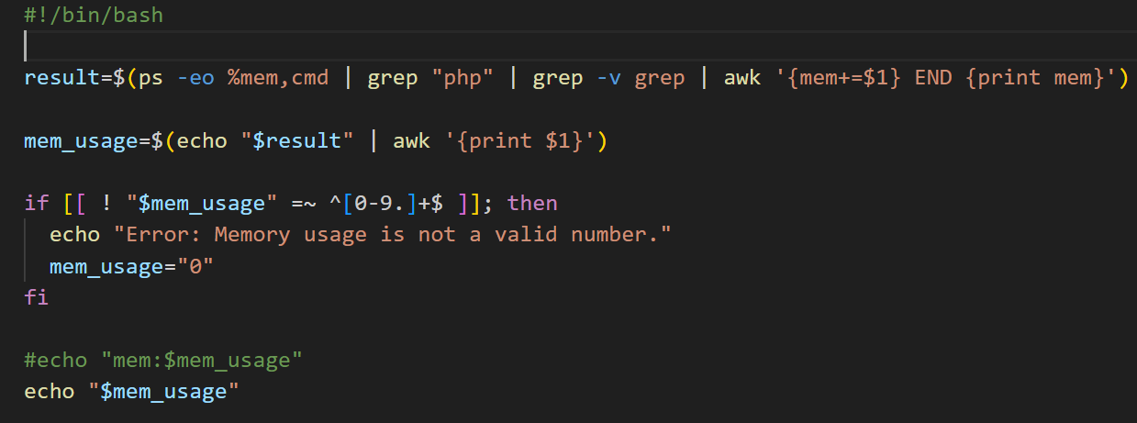

* 1. Cacti Server, 172.17.32.16, setup for CPU, Memory usage display on Cacti server:
     1. Input Method

Click “+” Add button to create input method:

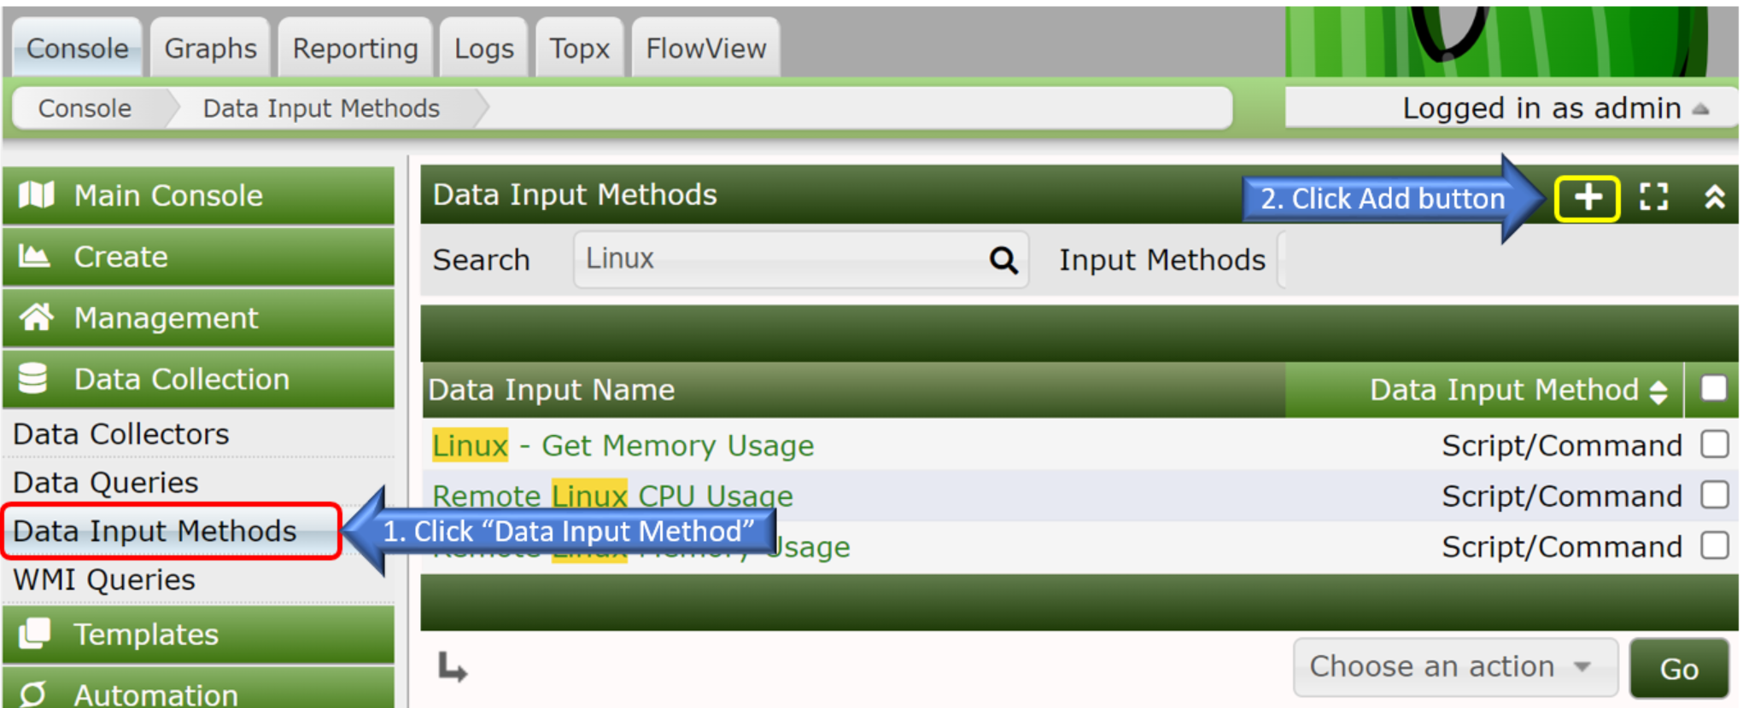

* + - 1. CPU and Memory Input Method Creation.

Click “+” Add button to create input method:

* Name: “Remote MariaDb CPU Usage” (User define).
* Input Type: “Script/Command” selected.
* Input String: Call “172.17.32.18 get_cpu_script.sh” script.
* Click “Create” button to create “Data input method”.

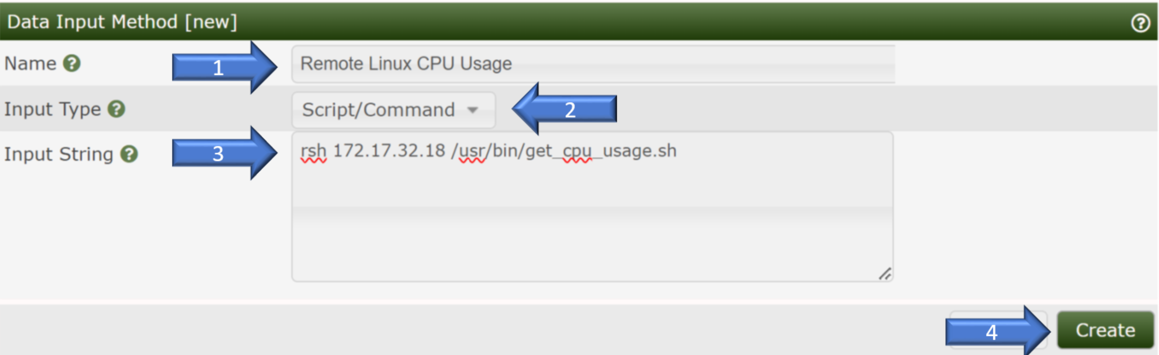

“Output Fields” Define:

Click “Output Fields” “+” button to create output field.

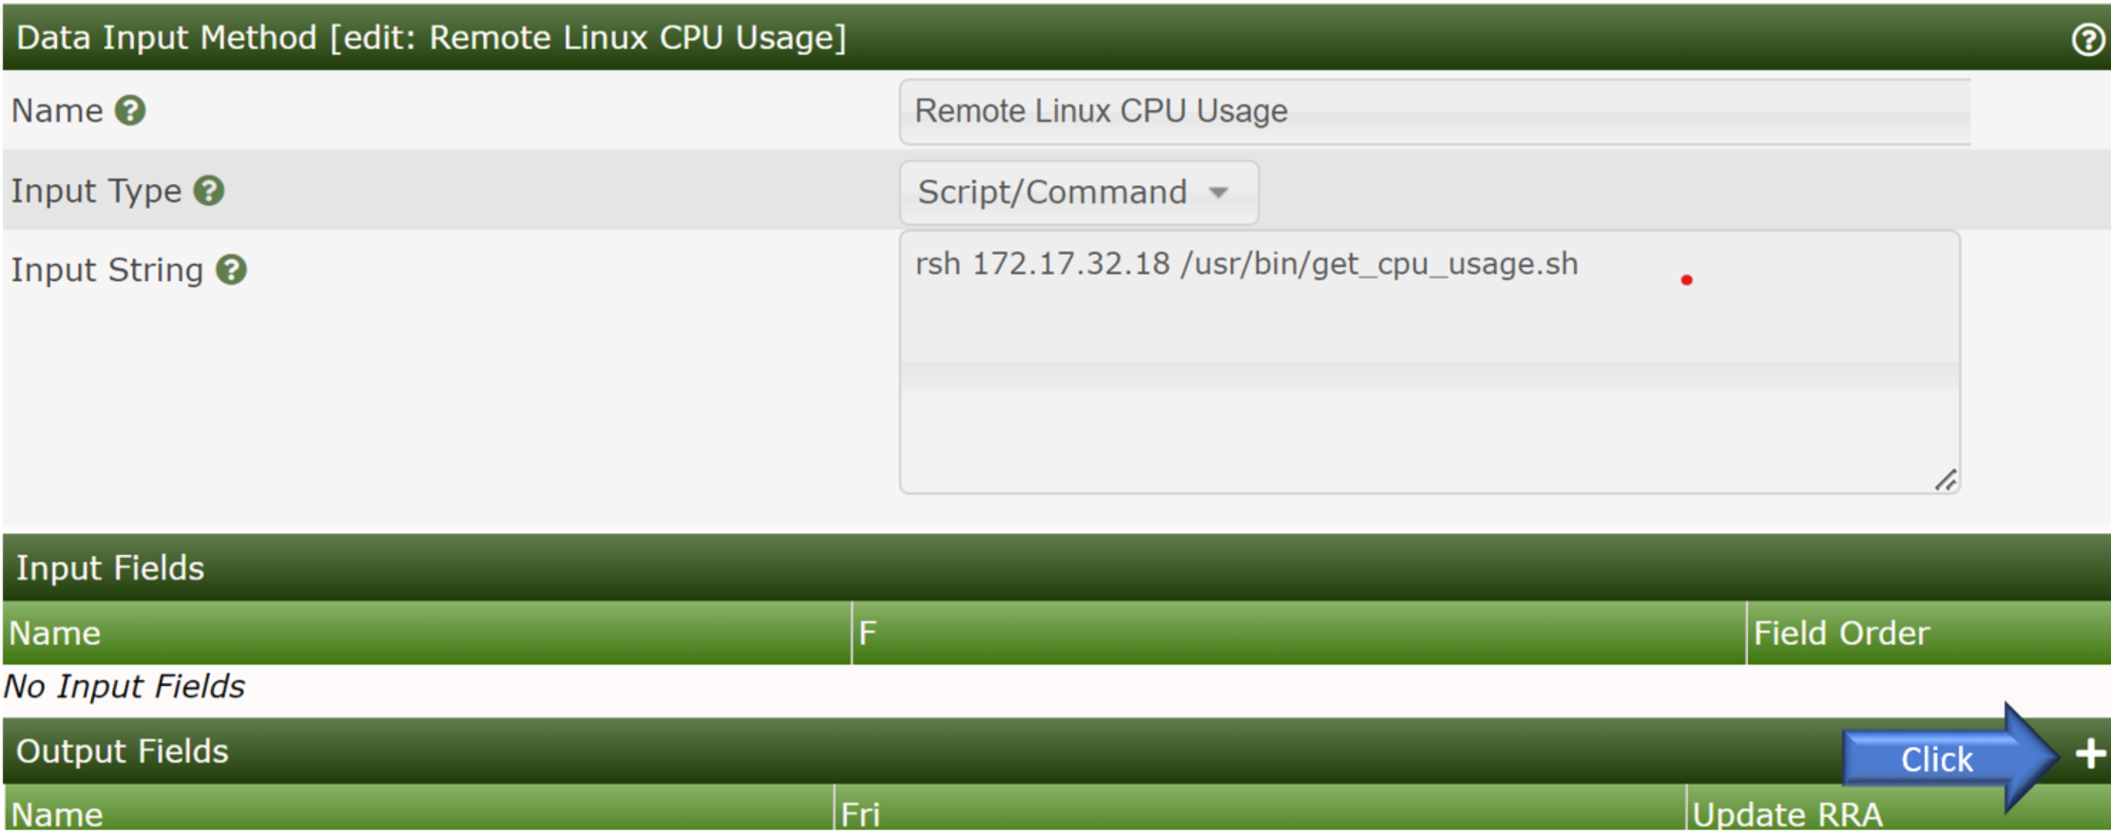

* Field: “cpu” (user define).
* Friendly Name: “cpu usage” (user define).
* Update RRDfile: “enabled”.
* Click “Save” button.

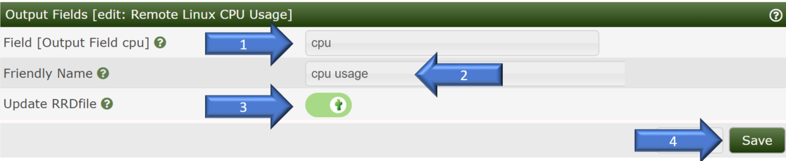

Click “+” Add button to create input method:



* Name: “Remote Linux Memory Usage” (User define).
* Input Type: “Script/Command” selected.
* Input String: Call “172.17.32.18 get_mem_script.sh script”.
* Click “Create” button to create “Data input method”.

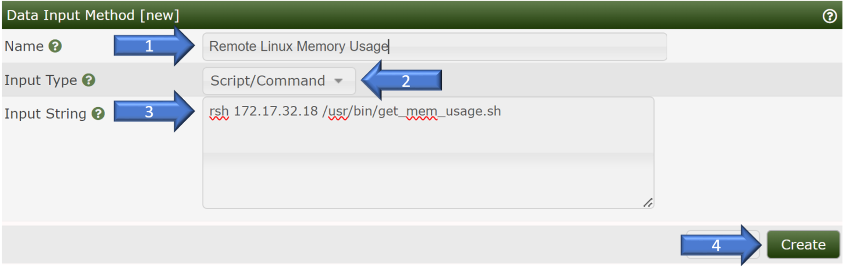

Click “Output Fields” “+” button to create output field.

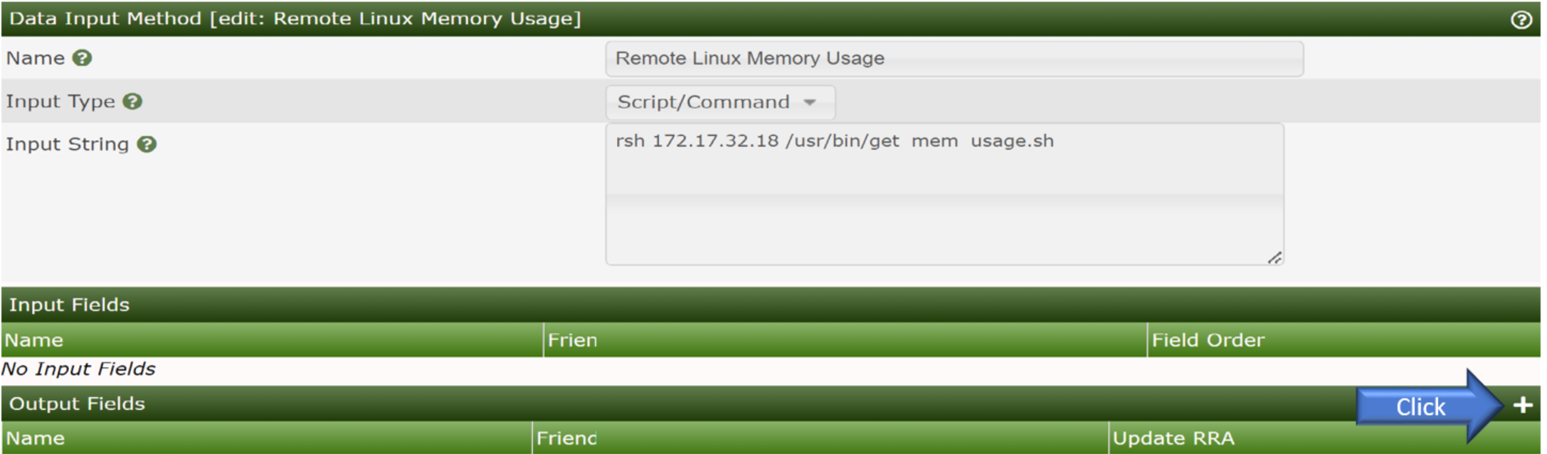

* Field: “mem” (user define).
* Friendly Name: “Memory usage”(user define).
* Update RRDfile: “enabled”.
* Click “Save” button.

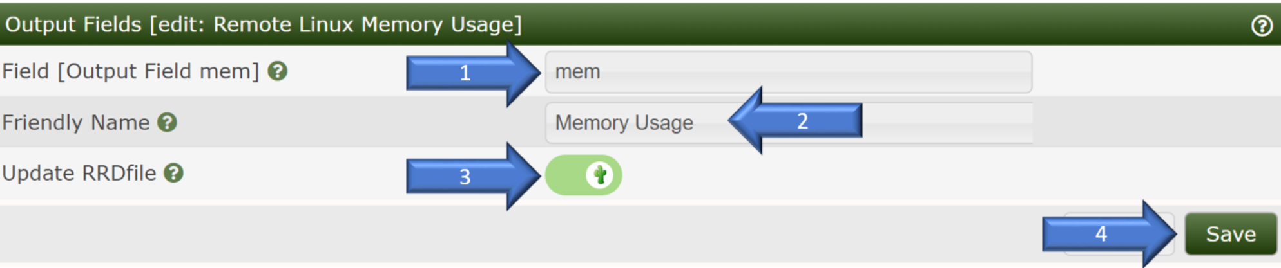

* + 1. CPU Memory Data Template Creation

Data Source Setup: Console 🡪 Template 🡪 Data Source🡪 “+” add button.

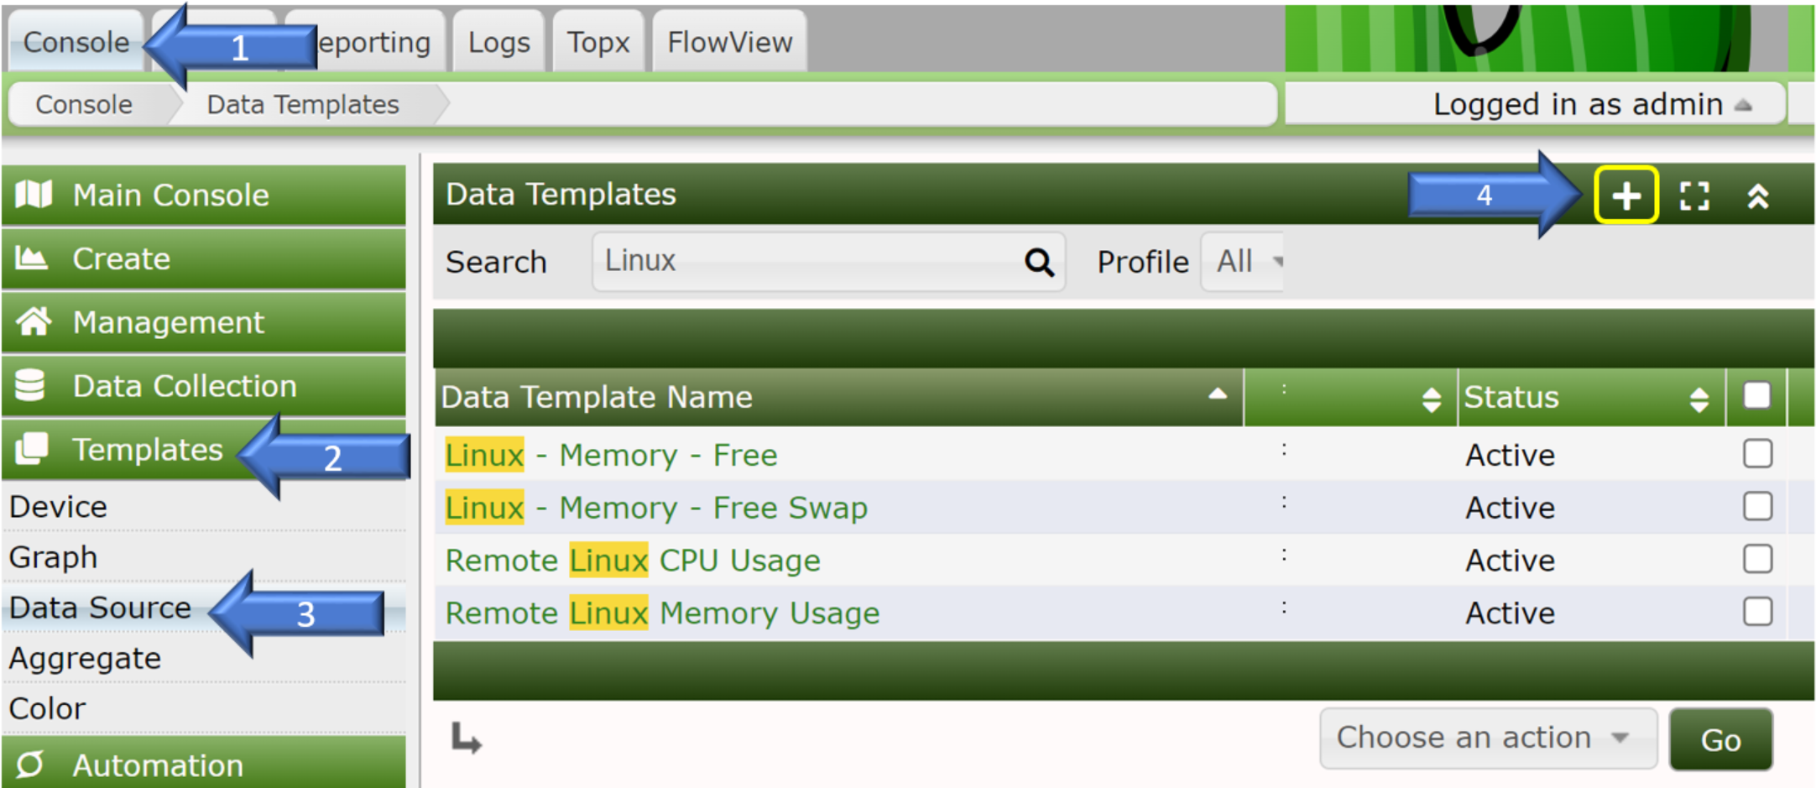

* Data Templates Name: “Remote Linux CPU Usage” (User define).
* Data Source Name: “Remote Linux CPU Usage” (User define).
* Data Input Method: “Remote Linux CPU usage” selected which defined on input method.
* Click “Create” button.

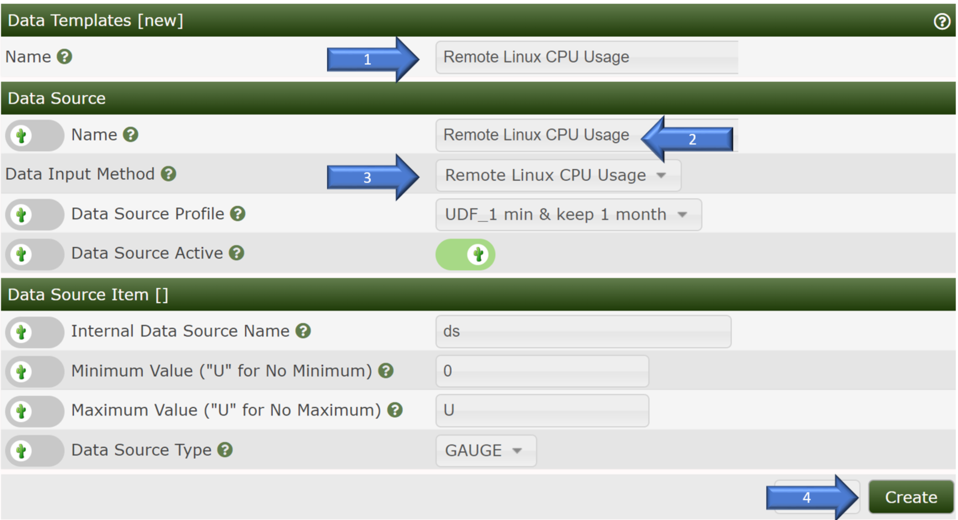

Data Source Item[]:

* Output Field: “cpu-cpu usage” selected. ( Internal Data Source Name: “cpu” which need same as the value on input method output field.)
* Click “Save” button.

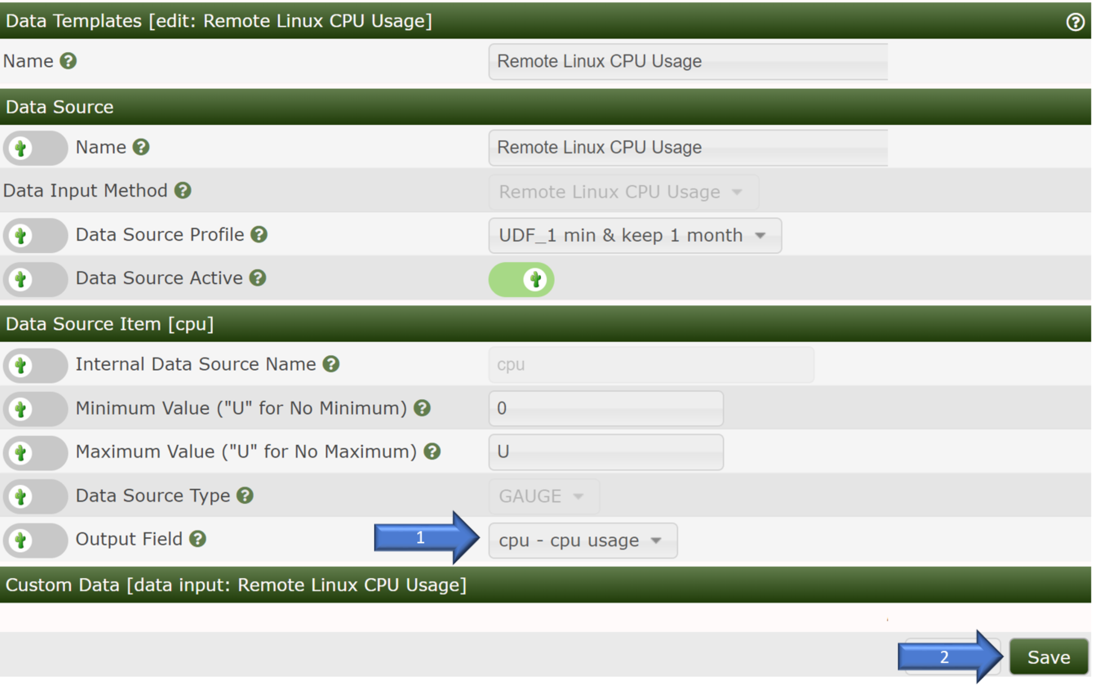

Data Source Setup: Console 🡪 Template 🡪 Data Source🡪 “+” add button.



* Data Template Name: “Remote Linux Memory Usage” (User define).
* Data Source Name : “Remote Linux Memory Usage” (User define).
* Data Input Method: “Remote Linux Memory usage” selected which defined on input method.
* Click “Create” button.

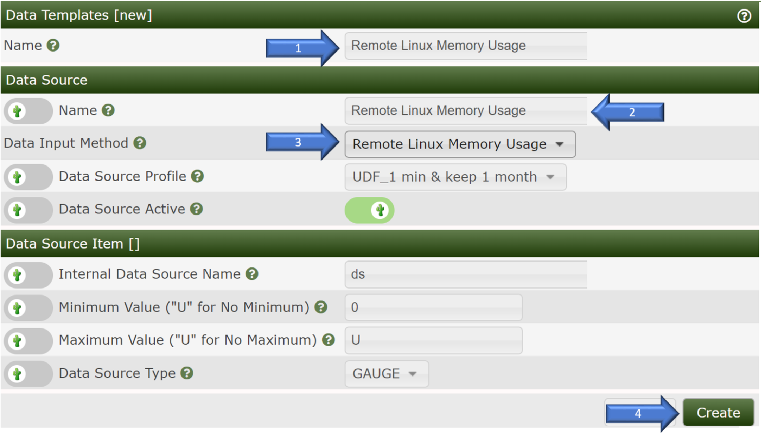

* Output Field: mem-Memory Usage selected. ( Internal Data Source Name: “mem” which need same as the value on input method output field.)
* Click “Save” button.

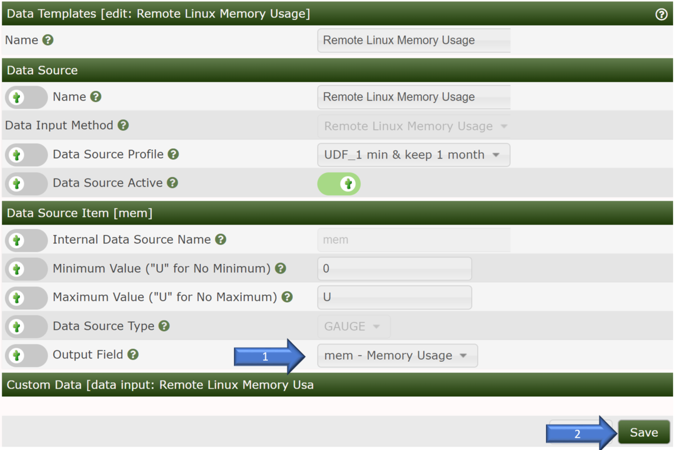

* + 1. CPU Memory Graph Template Creation

Console 🡪 Template 🡪 Graph 🡪 “+” to create Graph Template.

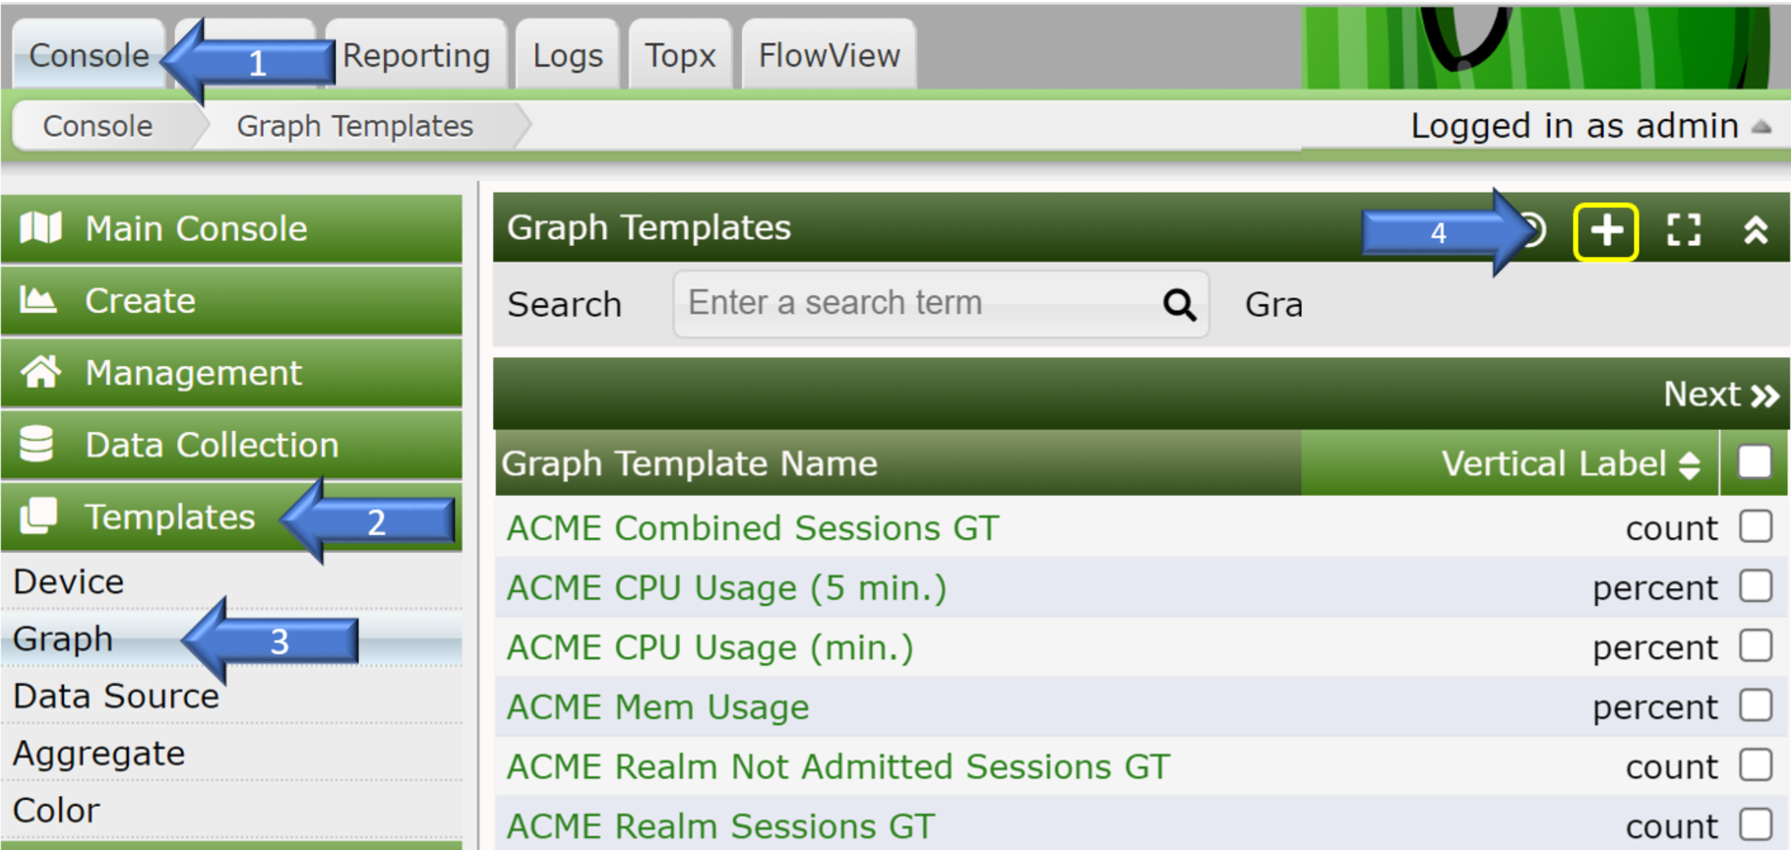

* Graph Template Name: “Remote Linux CPU Usage” (User define).
* Click “Create” to create graph template.

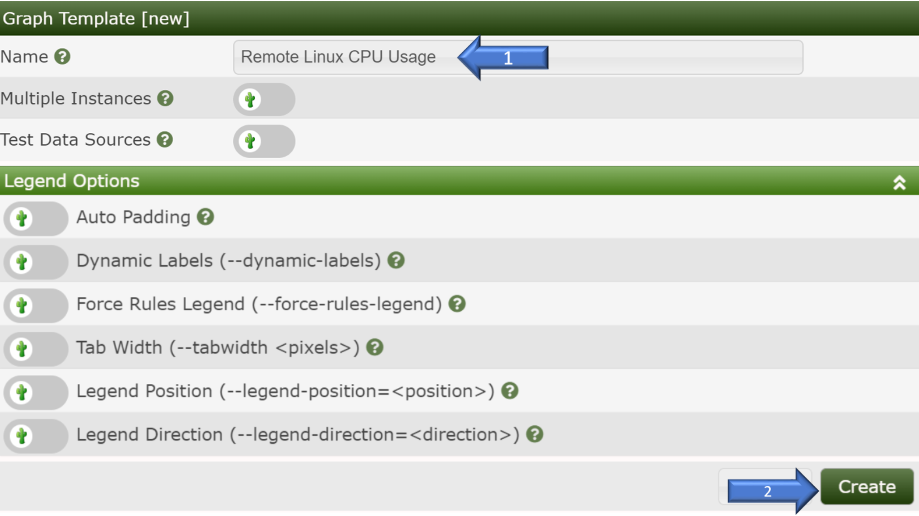

CPU Graph Template Creation:

* Click “Graph Template Items” add button “+”.
* Data Template Filter: “Remote Linux CPU Usage” selected.
* Graph Item Type: “LINE1” selected.
* Data Source: “Remote Linux CPU Usage-(cpu)” selected.
* Consolidation Function: “LAST” selected.
* Click “Save” button.

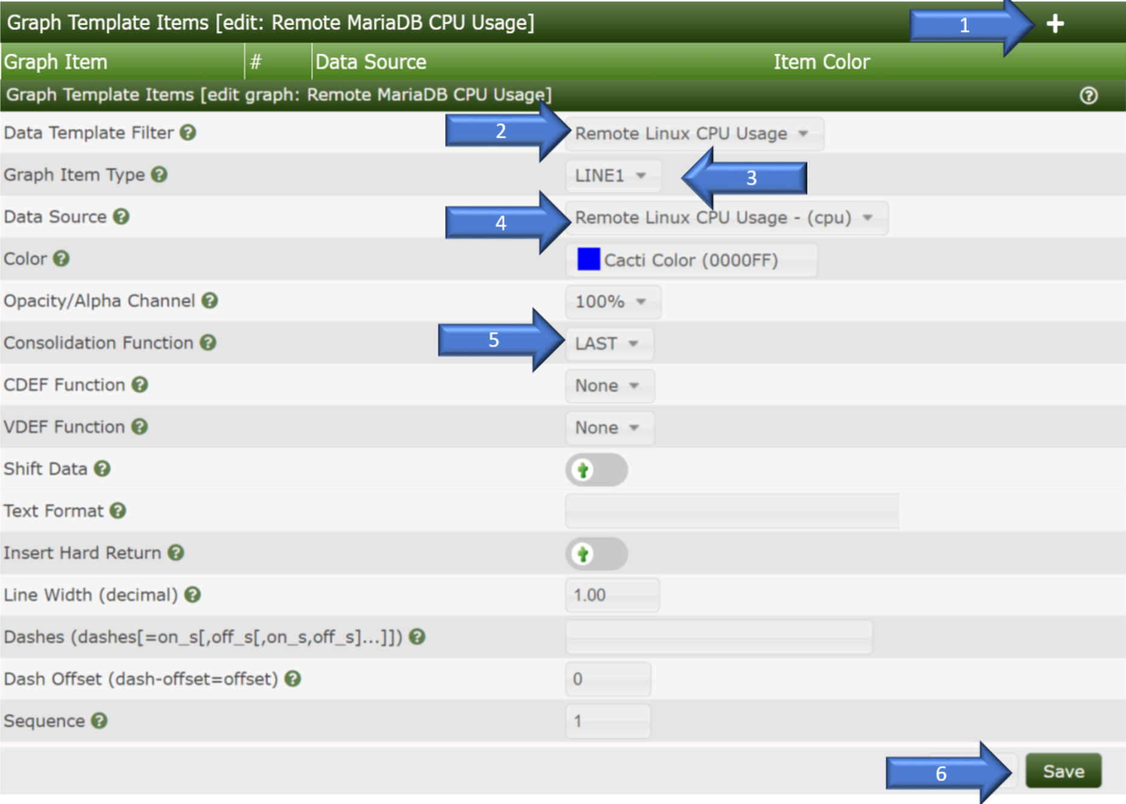

* Click “Graph Template Items” add button “+”.
* Data Template Filter: “Remote Linux CPU Usage” selected.
* Graph Item Type: “CPRINT” selected.
* Data Source: “Remote Linux CPU Usage-(cpu)” selected.
* Consolidation Function: “LAST” selected.
* CPRINT TYPE: “Percent” selected.
* Text Format: “CPU Usage” inputted.
* Click “Save” button.

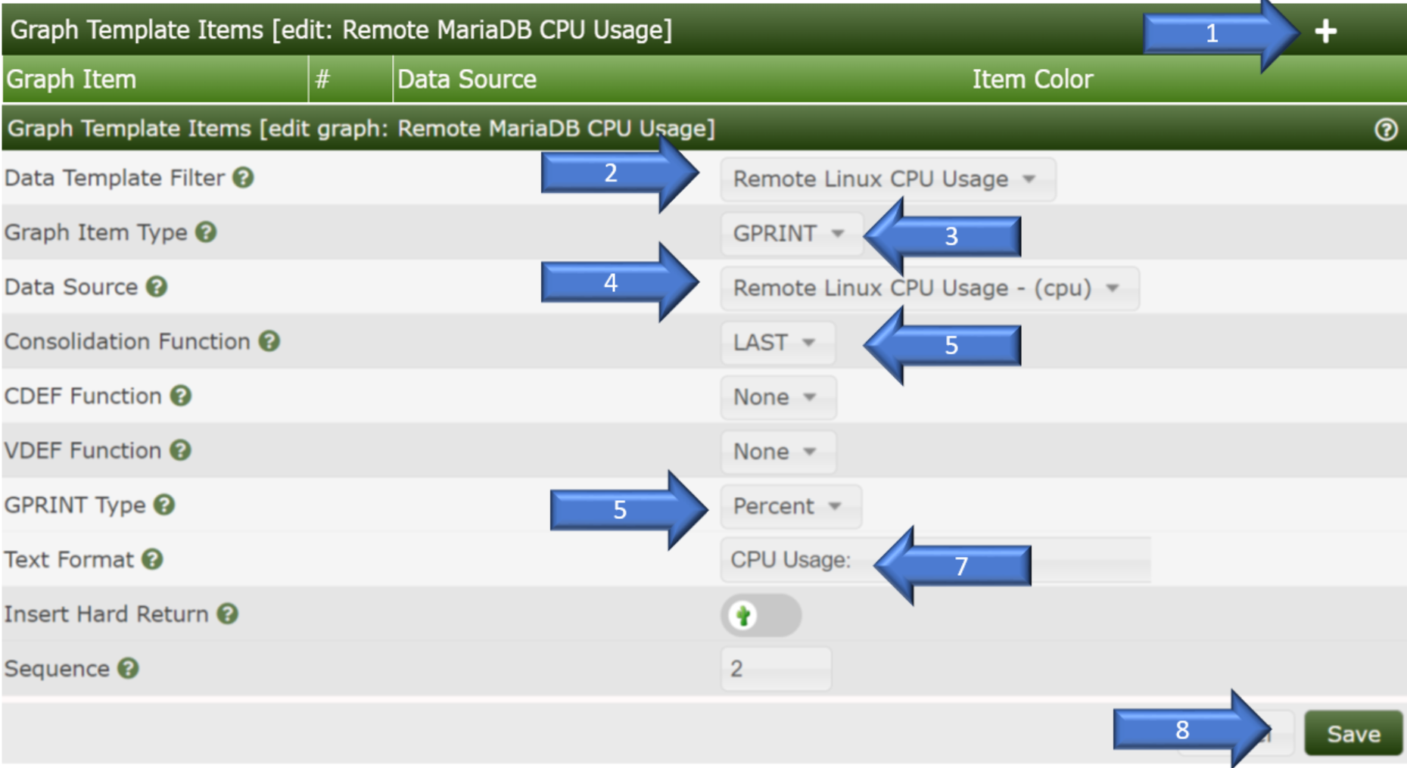

Memory Graph Template Creation:

Console 🡪 Template 🡪 Graph 🡪 “+” to create Graph Template.



* Graph Template Name: “Remote Linux CPU Usage” (User define).
* Click “Create” to create graph template.

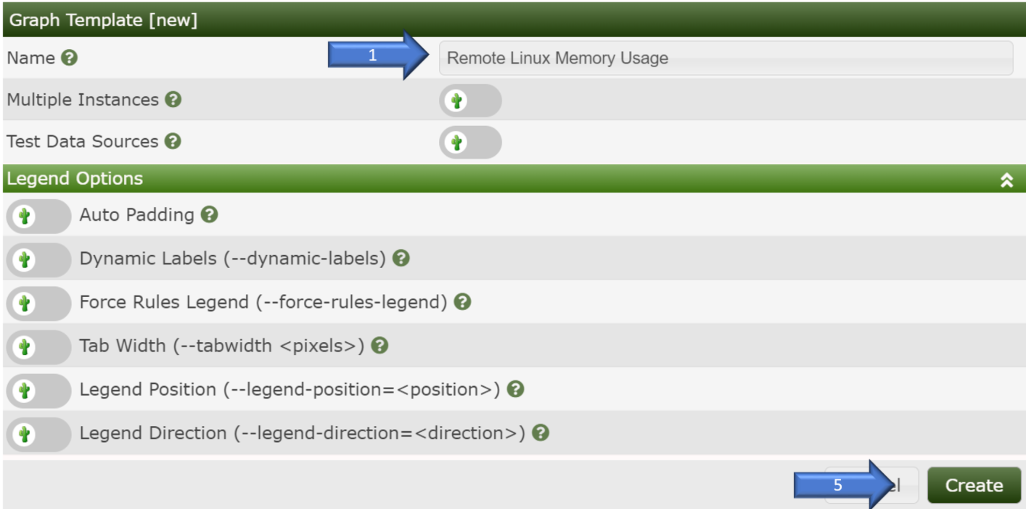

* Click “Graph Template Items” add button “+”.
* Data Template Filter: “Remote Linux Memory Usage” selected.
* Graph Item Type: “LINE1” selected.
* Data Source: “Remote Linux Memory Usage-(mem)” selected.
* Consolidation Function: “LAST” selected.
* Click “Save” button.

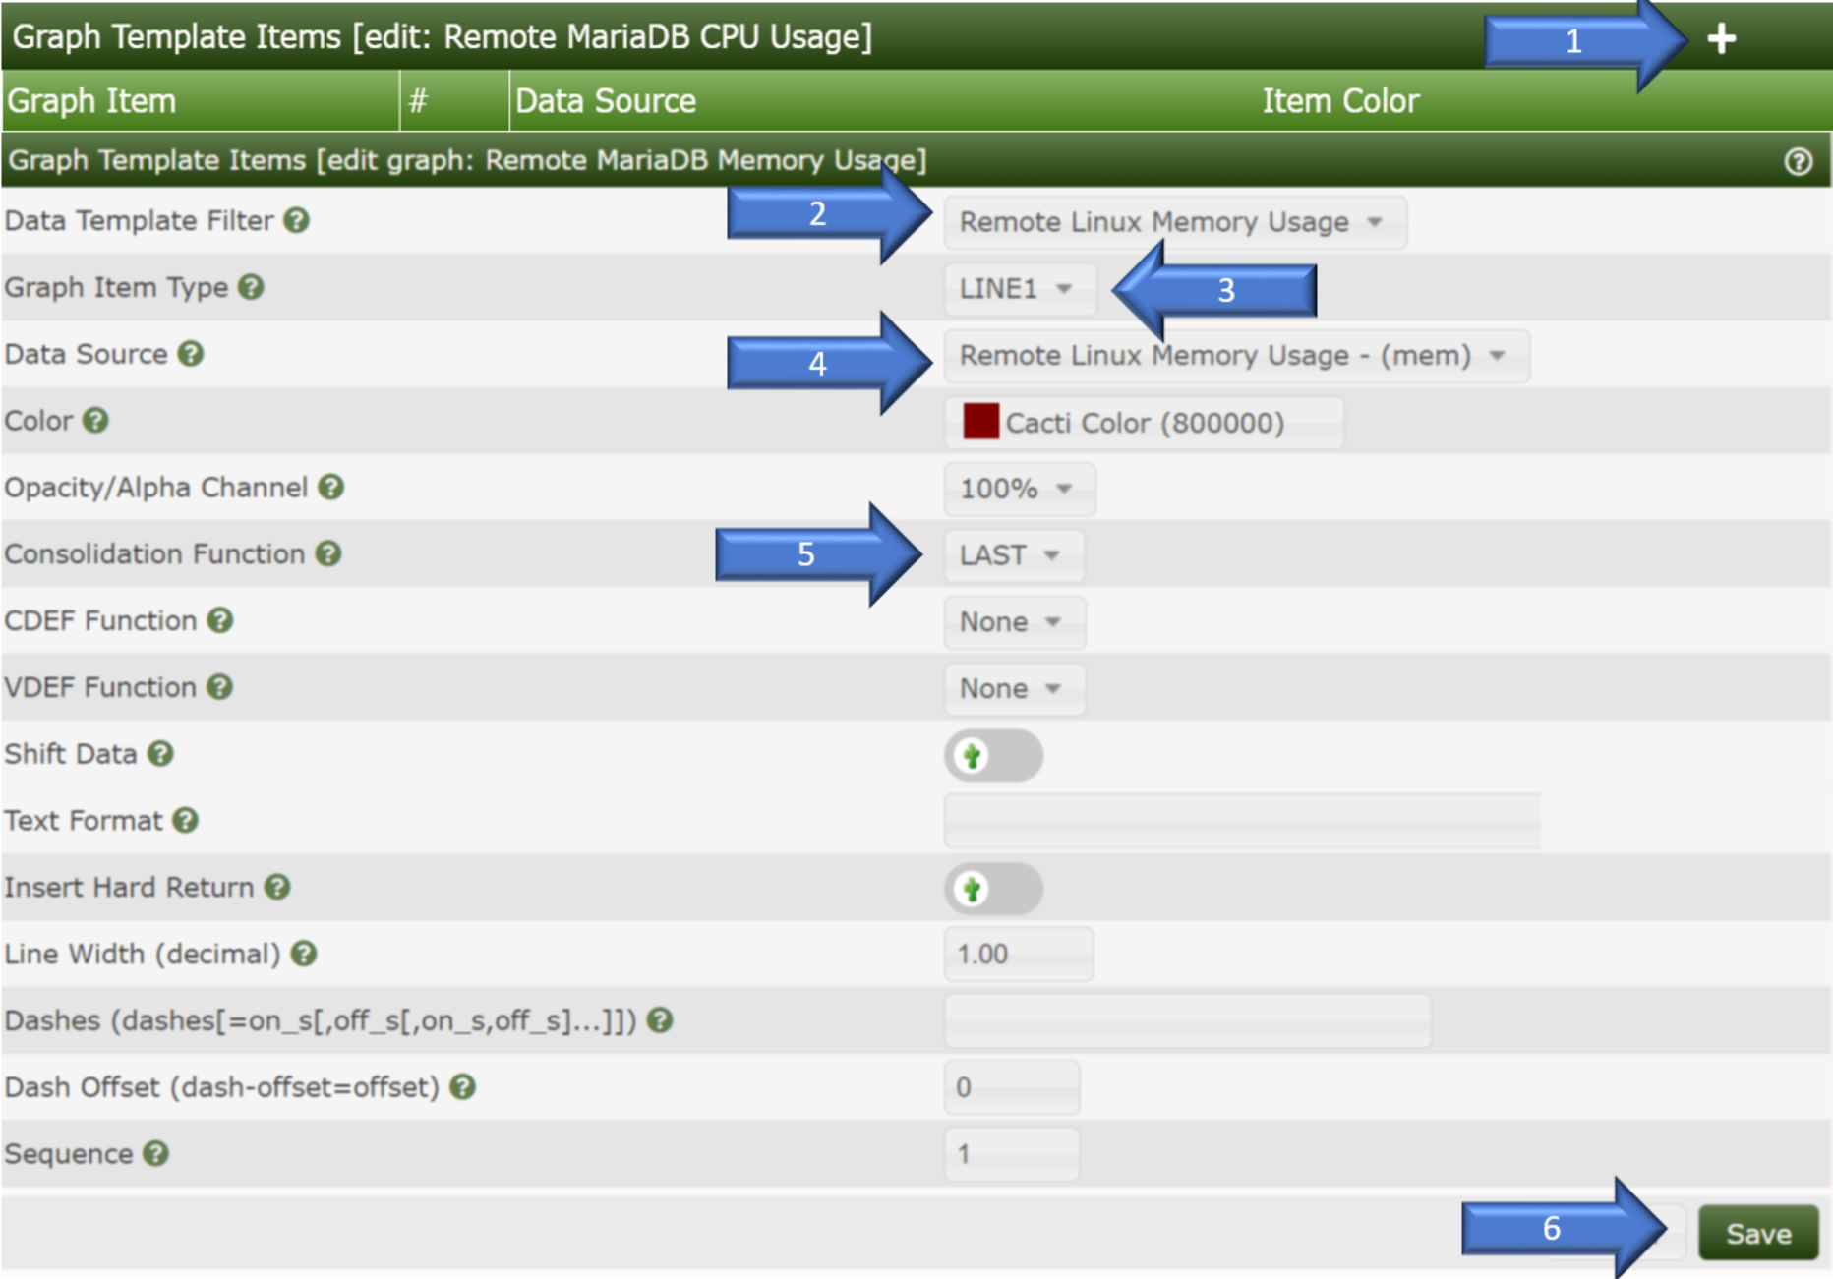

* Click “Graph Template Items” add button “+”.
* Data Template Filter: “Remote Linux Memory Usage” selected.
* Graph Item Type: “CPRINT” selected.
* Data Source: “Remote Linux Memory Usage-(mem)” selected.
* Consolidation Function: “LAST” selected.
* CPRINT TYPE: “MB” selected.
* Text Format: “CPU Usage” inputted.
* Click “Save” button.

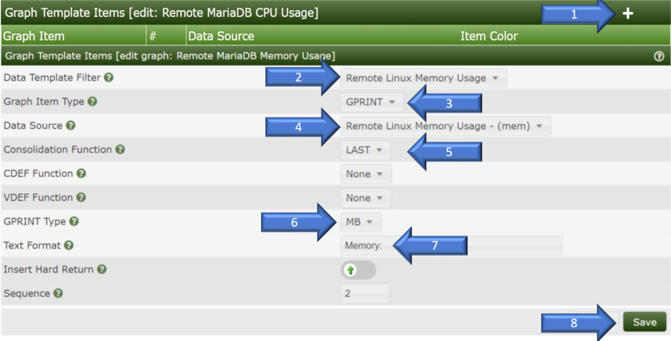

* + 1. Host Graph Creation:
* “Console”: selected
* “Management”: selected.
* “Devices”: selected.
* Click “+” to add new device.
* “Description”: user defined.
* “Hostname”: IP address
* Add “Remote Linux CPU Usage” to “Associated Graph Templates.”
* Click “Add” button.
* Add “Remote Linux Memory Usage” to “Associated Graph Templates.”
* Click “Add” button.
* Click “Save” button.

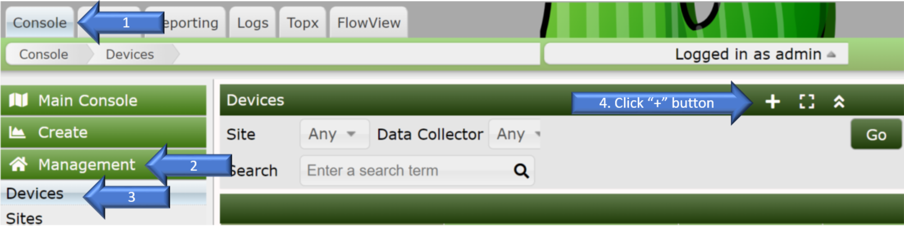

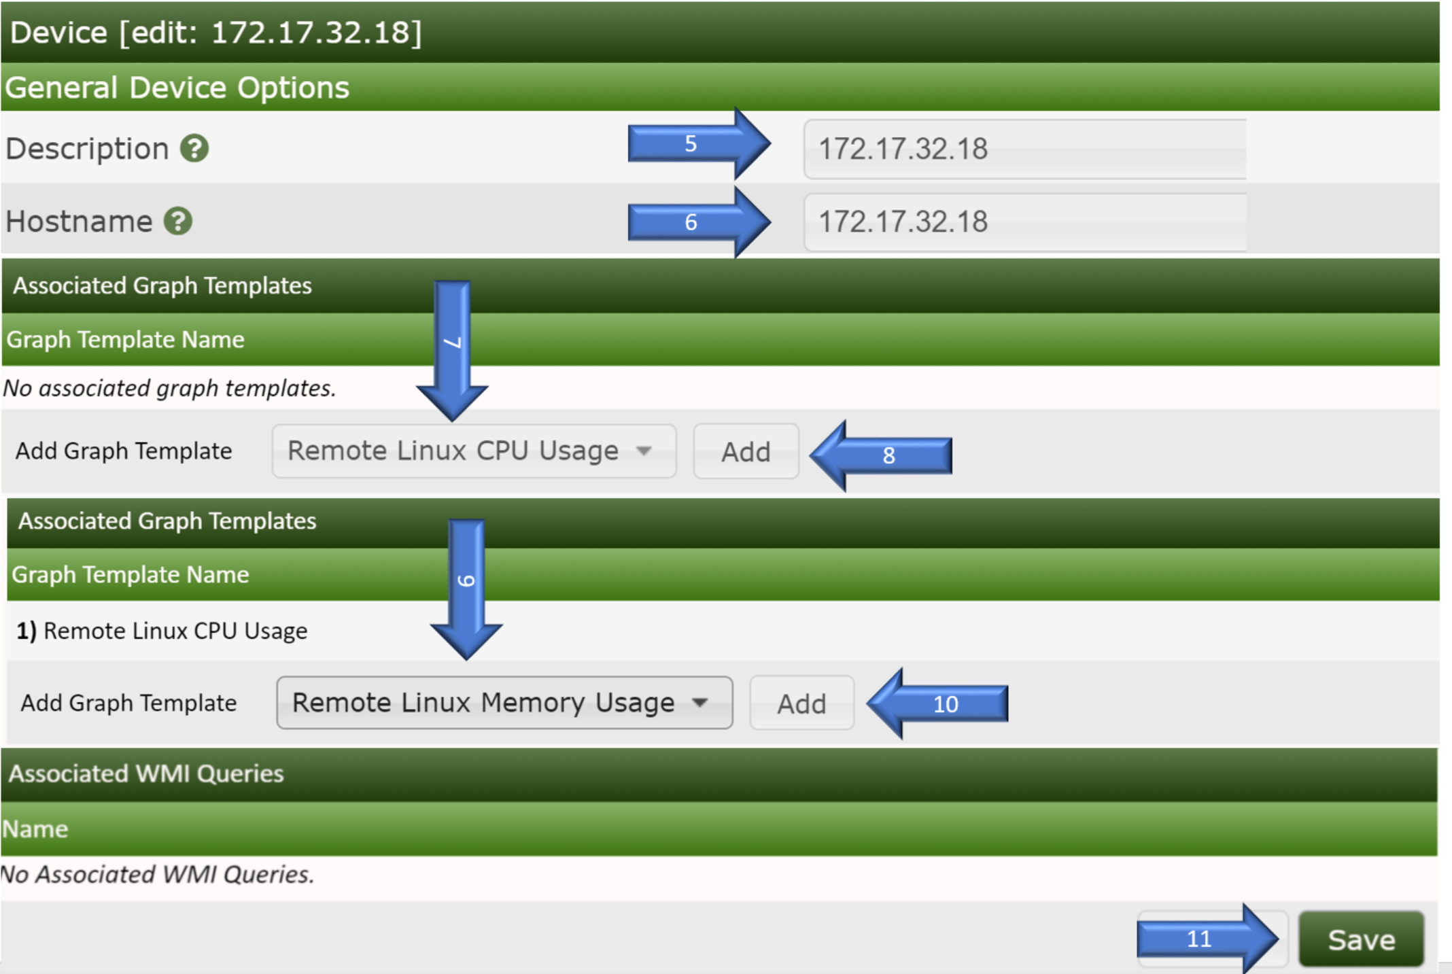

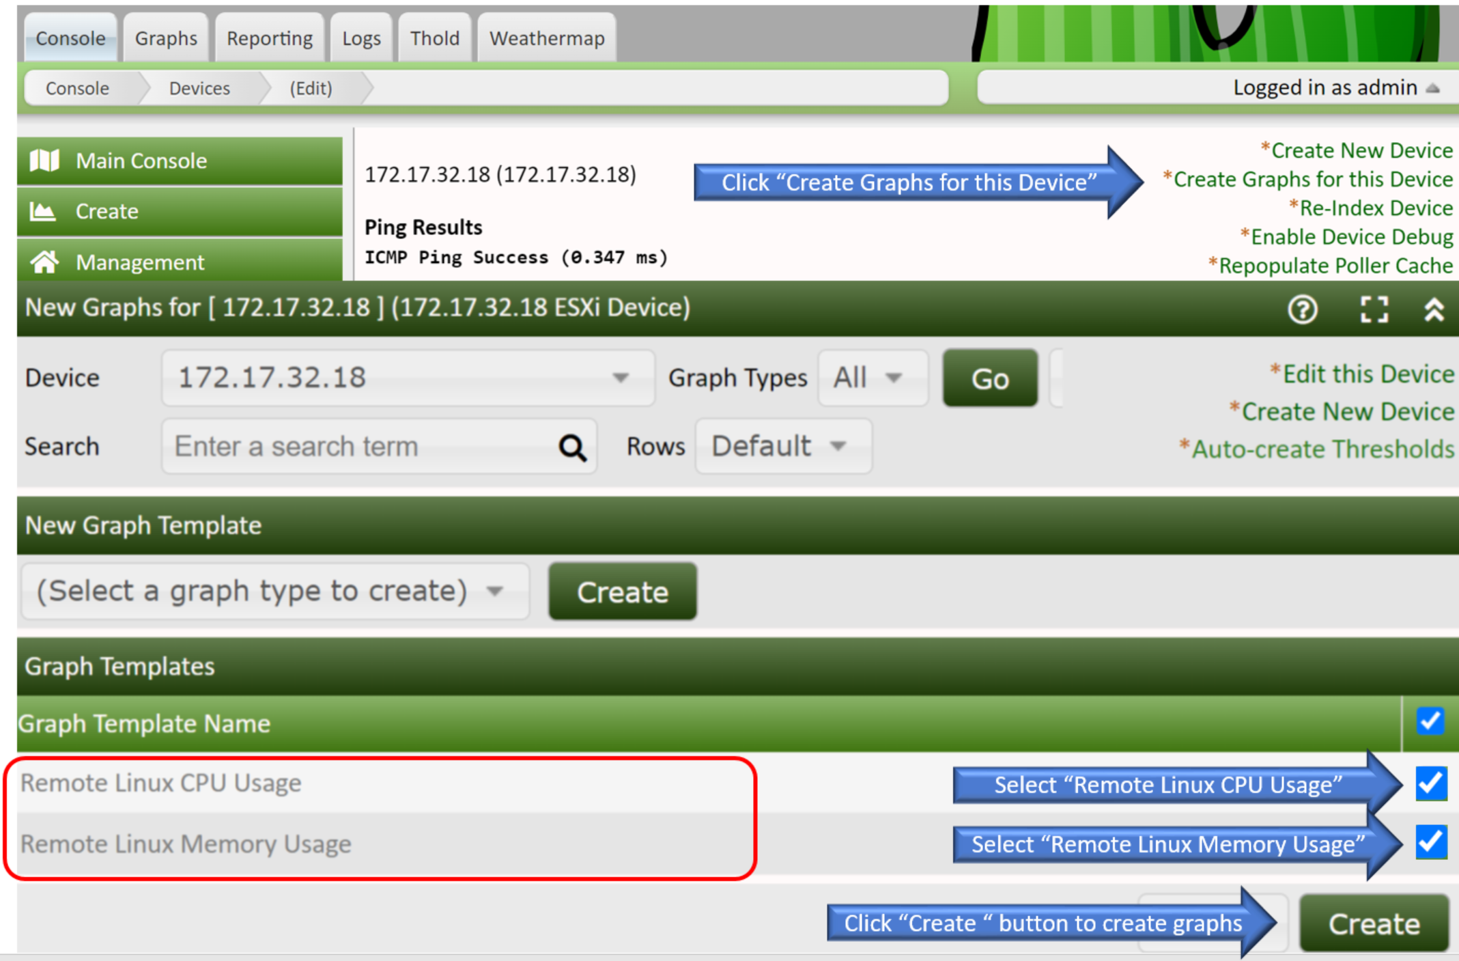

* + - 1. 172.17.32.18 CPU-Memory Usage Graphs created.



1. **Attachment：**

None.